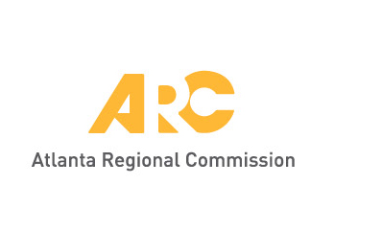Union City Community Garden

Public Open House

January 8, 2019

Union City City Hall

Goals for the Meeting:

* Explore the opportunities for developing a community garden in Union City, including distinguishing between models for community gardens and urban farms
* Identify the correct model for Union City based on model gardens, particularly those that are located in established city parks and recreation facilities
* Identify features typical garden features that should be considered/ replicated in a garden in Union City
* Gather feedback on other elements that should be considered in designing a garden for Union City

Activities:

* Goals and Timeline – This activity briefly describes the goals of the project and describes the activities undertaken so far.
* Model Gardens – Union City explored different models of community gardens and urban farms to bring together the ideas shared in this meeting. What other information would you be interested in knowing more about in this process?
* Garden Elements – Union City identified a combination of key elements from different gardens that could work to create a garden for the city. Share your thoughts on these elements, as well as other ideas for introducing urban agriculture into the city.
* Opportunities for Agriculture – multiple sites were assessed for their suitability for agriculture throughout the city. These included things like access to water, hours of sunlight and other activities present on the site. What do you think of the identified opportunities? Where else are their opportunities to include urban agriculture in Union City?
* Other Thoughts – please share any final thoughts or ideas that you may have about a community garden, or any other aspect of urban agriculture in Union City.