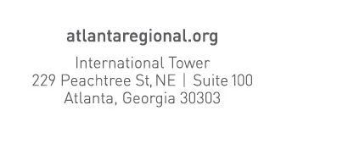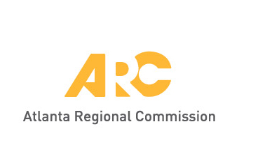Union City Community Garden Manual

Steering committee Meeting

September 24, 2018

Union City City Hall

Goals for the Day:

* Explore the opportunities for developing a community garden in Union City
* Identify the correct model for Union City
* Clarify scope elements and timeline

Agenda:

1. Recap of August 8 Meeting
2. Review of Potential Sites
3. Tuesday, October 9 – meeting with coordinators of community gardens in Norcross and McDonough
   1. Other Topics?
4. Other Discussion