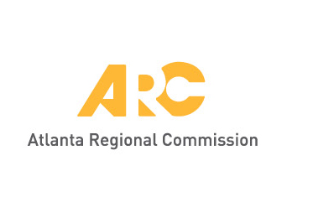

* Where is the site for the community garden?
  + Union City has a lot of donated land
    - Could be potential sites for the community garden
  + There are many facilities in the city that could serve as sites for the garden
  + Since many potential sites exist, there could be multiple small sites throughout the city
    - Will help develop the urban agriculture base
    - Incremental planning towards the showcase garden
    - Small sites
      * Fruit trees at multiple facilities
      * A few beds at a park, community center, and senior center
* Concerns
  + Keeping people away from private plots
  + Preventing vandalism
  + Obtaining volunteers
    - May not have that much community support
    - Not many big projects have be implemented that required a large amount of community support/volunteers
    - Will the garden have enough resources (UC staff, funds, volunteers) to sustain the garden over time?
    - Will the garden need a fence? Security concerns – other sites where landscape has been installed has been vandalized
  + Rebranding Union City – “Your Union City”
    - The community garden could begin to change perceptions of Union City
* Resources
  + Most of the UC staff do not have the resources and extra time to commit to the project
    - Solution: hiring people for the garden; contracting employees from other farms
      * Captain Planet provides garden/farm maintenance for school gardens
  + Volunteers
    - Parks and Rec. has some loyal volunteers
      * Volunteers do not have gardening experience
      * South Fulton Master Gardeners may be a good resource
      * There are citizens who help with planting flowers
        + Could they be the champion
    - Staff is unfamiliar with the existence of civic organizations in the city
    - Public Services can offer trash pick up
  + Corporate Partners in the area, including food companies, Amazon, Google
* Governance
  + Would there be a need for the creation of a formal Board
    - There will be a YMCA board by the end of the year